**Convert Octal to Decimal**

**EXP .NO :30**

**PROGRAM:**  
#include<stdio.h>

#include<math.h>

int OctalToDecimal(int n) {

int p = 0, decimal = 0, r;

while(n>0){

r = n % 10;

n = n / 10;

decimal = decimal + r * pow( 8 , p );

++p;

}

return decimal;

}

int main() {

int n, i, k;

printf("Enter Octal: ");

scanf("%d", &n);

printf("\nDecimal of Octal Number %d is : %d", n, OctalToDecimal(n));

return 0;

}

**INPUT:**

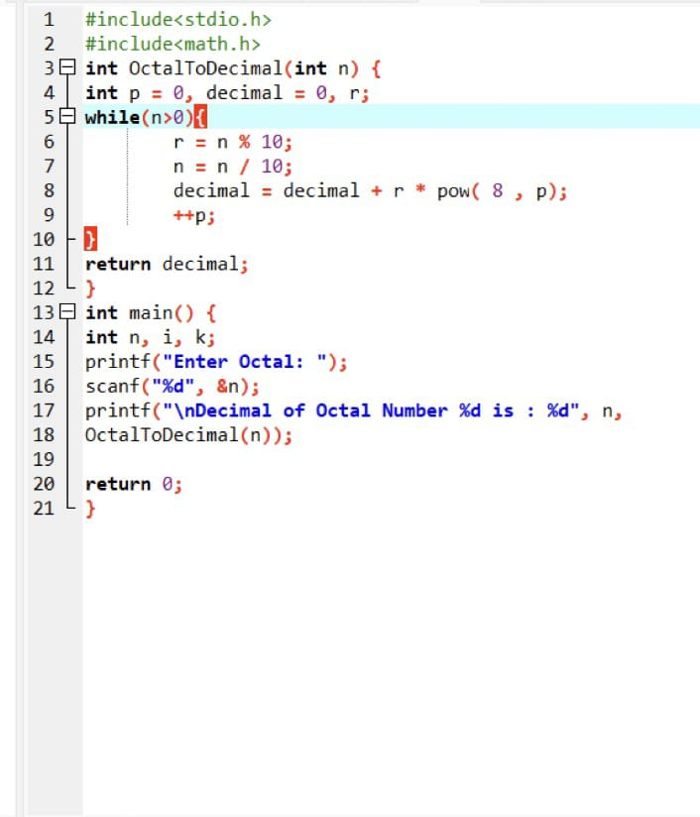

**OUTPUT:**

